109062318簡弘哲

1. Stack changes before and after ThreadCreate call

According to .map file, the address of _ThreadCreate is 00AE, so I set a breakpoint there and SP is 0x09 now

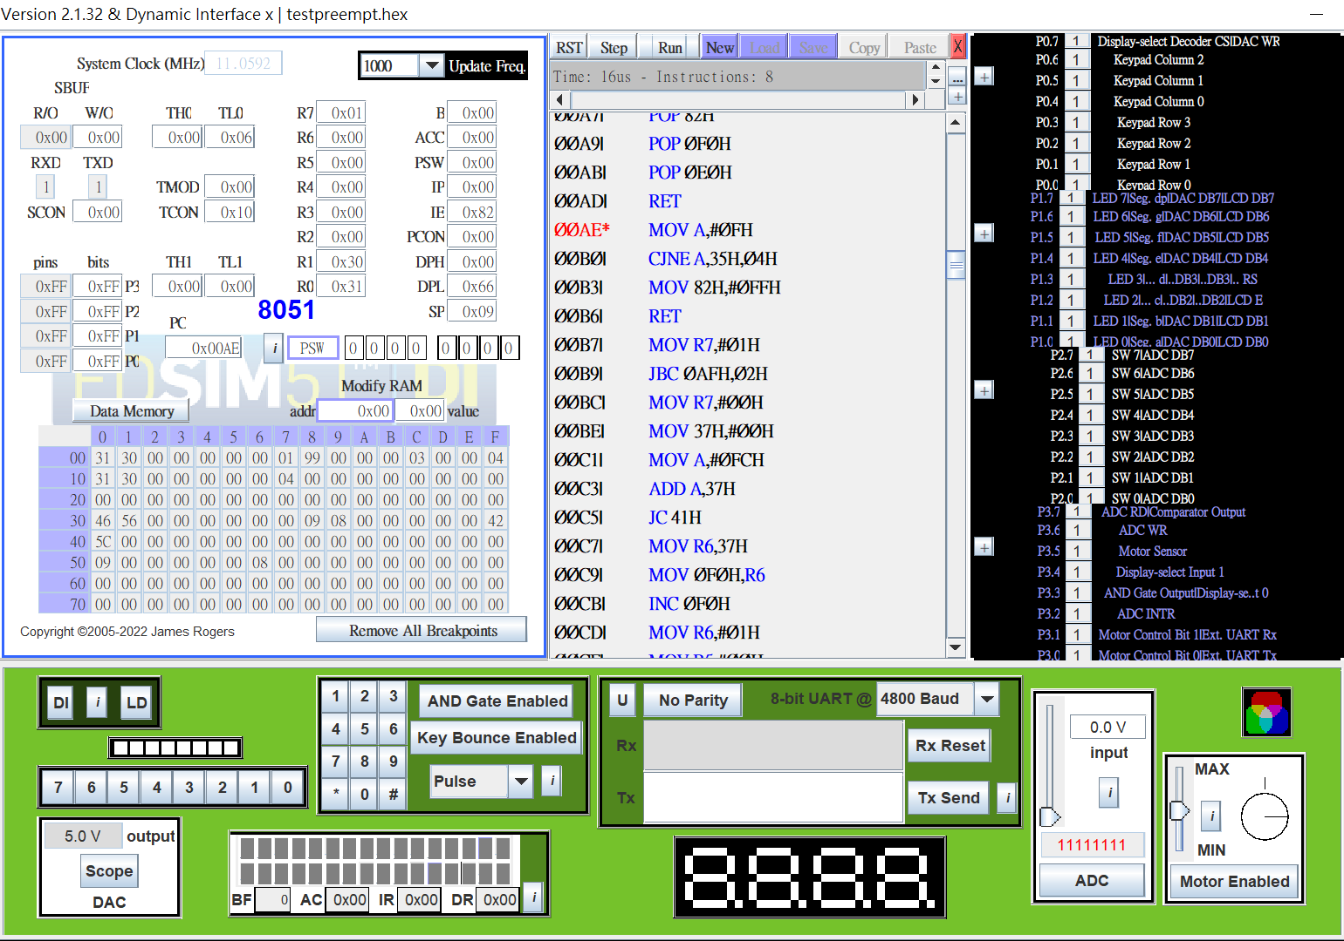

After I press step button several times, I came to the red block part, which change the SP to 0x3F(SP address = 81H)

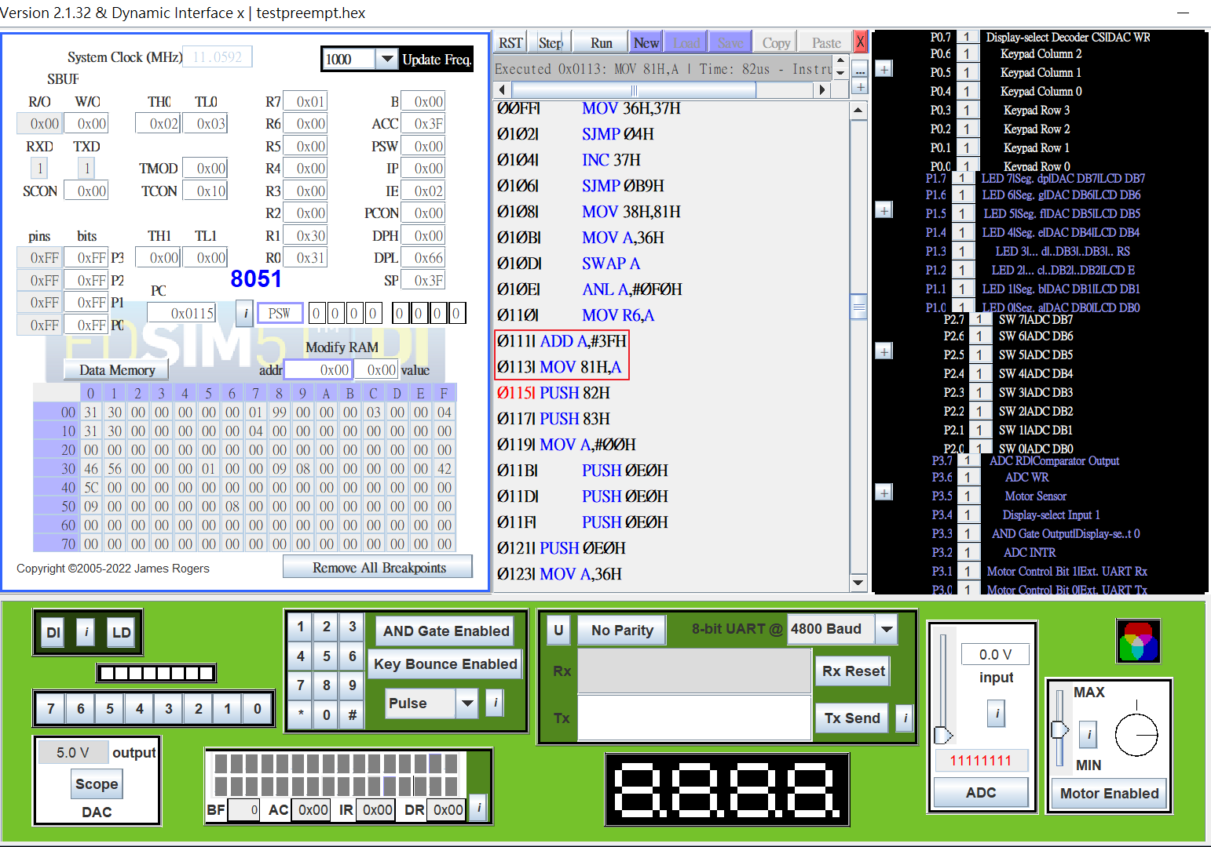

1. Producer running

According to .map file, the address of _Producer is 0014, so I set a breakpoint there, and the red block corresponds to the code that I init the variable ch=’A’

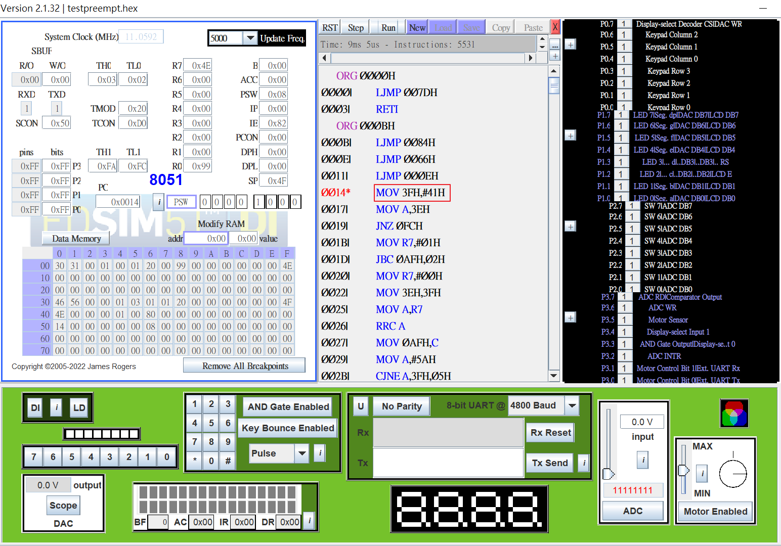

1. Consumer running

According to .map file, the address of _Consumer is 003B, so I set a breakpoint there and the red block corresponds to the code that I initialize TMOD, TH1,…

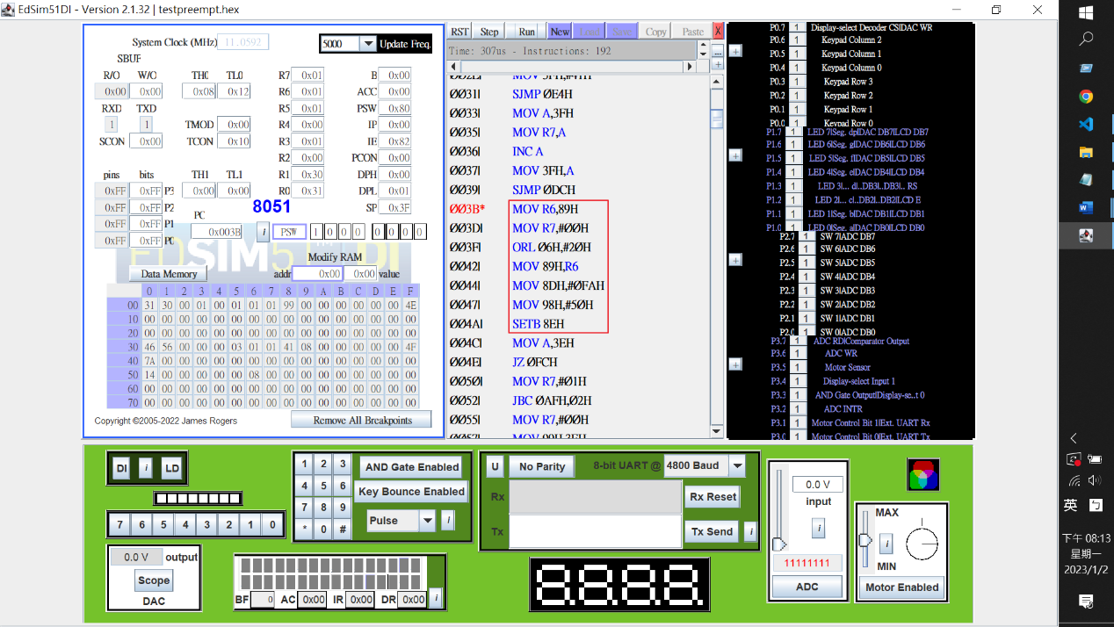

1. Interrupt triggering

We can observe TH0,TL0 since T0 is for preemption. We have “TMOD |= 0x20” in Consumer, which choose mode 2(8-bit auto reload) for timer

1. Typescript

